# Question Set 01

### **Thermodynamics and Heat Transfer Basics**

1. Air flow enters a heat exchanger at the rate of 3.5 kg/s and at a temperature of 24oC. The air leaves the heat exchanger at 75oC. At what rate is heat transferred to the air ? You may assume that the air has constant specific heat Cp = 1.00 kJ/kg.K.   
   [Ans 178.5kW]
2. Water flows into a heater at 1.2 litres per second at 18oC. The heater is rated at 2.5 kW. What will be the temperature of the water leaving the heater? Take 1 litre of water = (1/1000) m³, and the density of water = 1000 kg/m³. Obtain Cp from your textbook or tables.

[Ans 18.5oC]

1. The wall of a cold room is composed of three layers: The outside layer is brick 0.21 m thick, the middle layer is cork 0.10 m thick, and the inside layer is cement 0.050 m thick. The wall is 2 m high and 5 m long. Thermal conductivities are: brick 0.70; cork 0.44; cement 1.15 W/(m.K). The temperature of the outside air is 27°C and the inside air is -23°C. The convective film coefficients are 48 W/(m².K) for the outside air to brick and 17 W/(m².K) for the inside air to cement. Determine:

a) the thermal resistance of the wall including the air boundary layers

b) the overall heat transfer coefficient

c) the rate of heat flow under steady conditions

d) the temperature on the internal wall surface.

[Ans (a) 6.503 × 10-² K/W, (b) 1.538 W/m². K, (c) 769W, (d) -18.5°C]

1. Waste steam from a turbine exhausting at atmospheric pressure into a chamber is being used to heat water for building heating as it flows in tubes through the chamber. The average mean (bulk) water temperature in the tubes is 90°C and the flow rate is 300 kg/min. The steel tube is 76 mm OD and 4.5 mm wall thickness and the conductivity of the steel is 50 W/mK.

a) For forced convection heating inside tubes, for Re ≥ 10 000, Nu = 0.023Re0.8Pr0.4 Using this and the following data for water at 90°C, determine the convective film co-efficient inside the tubes: Pr = 1.93, ρ = 962 kg/m³, = 0.311 10¯³ kg/m.s, k = 0.676 W/m.K.

Using the results from (a) and given that the convection coefficient for steam condensing on the outside of the tubes is 10 000 W/m².K, the fouling factor on the steam side is 0.0001 m².K/W and on the waterside 0.0002 m².K/W, determine:

b) the total thermal resistance between steam outside and water inside for one meter of tube.

c) the % of the total resistance that is due to the convective film on the water (liquid) side.

d) The overall heat transfer co-efficient referred: (i) to the outside of the tube; (ii) to the inside of the tube.

e) the overall heat transfer co-efficient referred to the outside of the tube if the water (liquid) flow rate is halved. Compare to (d).

[Ans (a) h = 7377 W/m².K, (b) 2.833 × 10-³ K/W, (c) 22.7%, (d) (i) 1478 W/[m² (of outside area) . K] (ii) 1677 W/[m² (of inside area) . K], (e) 1265 W/[m²(outside) . K], which is a 14% reduction from 1478 W/m².K ]

### **COP trends in Vapour Refrigeration Cycles**

1. What happens to the COP of a Carnot Refrigerator when the cold reservoir temperature is reduced and why?
2. Likewise what happens to the Carnot COP when the hot reservoir temperature gets higher?
3. What happens to the Coefficient of performance of the Vapour Compression cycle, when the evaporating temperature gets lower?
4. Similarly what happens to COP when condensing temperature changes and why?
5. Why are the vapour compression cycle COPs less than the corresponding Carnot COPs?

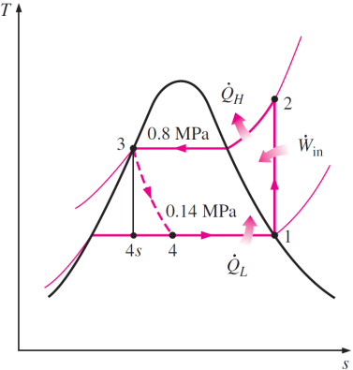

1. A refrigerator uses refrigerant-134a as the working fluid and operates on an ideal vapor-compression refrigeration cycle between 0.14 and 0.8 MPa. If the mass flow rate of the refrigerant is 0.05 kg/s, determine:  
   (a) the rate of heat removal from the refrigerated space and the power input to the compressor,   
   (b) the rate of heat rejection to the environment, and   
   (c) the COP of the refrigerator.

1. 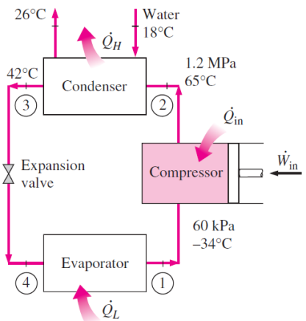A commercial refrigerator with refrigerant-134a as the working fluid is used to keep the refrigerated space at -30°C by rejecting its waste heat to cooling water that enters the condenser at 18°C at a rate of 0.25 kg/s and leaves at 26°C. The refrigerant enters the condenser at 1.2MPa and 65°C and leaves at 42°C. The inlet state of the compressor is 60 kPa and -34°C and the compressor is estimated to gain a net heat of 450 W from the surroundings. Determine:  
   (a) the quality of the refrigerant at the evaporator inlet,   
   (b) the refrigeration load,   
   (c) the COP of the refrigerator, and   
   (d) the theoretical maximum refrigeration load for the same power input to the compressor.

[Ans: (a) hf@18oC = 75.47 kJ/kg; hf@26oC = 108.94 kJ/kg; (b) Q = 5.85kW; (c) COP = 2.33; (d) Q = 12.72kW]

1. A refrigerator uses refrigerant-134a as the working fluid and operates on an ideal vapour compression refrigeration cycle between 0.12 and 0.7 MPa. The mass flow rate of the refrigerant is 0.05 kg/s. Show the cycle on a T-s diagram with respect to saturation lines. Determine   
   (a) the rate of heat removal from the refrigerated space and the power input to the compressor, (b) the rate of heat rejection to the environment, and   
   (c) the coefficient of performance.   
   [Ans: (a) 7.41 kW, 1.83 kW, (b) 9.23 kW, (c) 4.06]
2. Repeat Prob. 1.12 for a condenser pressure of 0.9 MPa.

[Ans: (a) 6.77 kW, 2.10 kW, (b) 8.87 kW, (c) 3.23]

1. The temperature in the refrigerated hold of a ship is -13°C and the heat rejected from the refrigeration cycle is passed to the sea which is at 17°C.

a) If the evaporator and condenser had infinite heat exchange area and the refrigerator worked on the reversed Carnot cycle what would the coefficient of performance of the refrigerator be? [Ans (a) 8.66]

b) If the heat exchange areas are reduced to a more reasonable size such that there is a 7°C difference between the evaporating fluid and the hold, and a 13°C difference between the condensing fluid and the entering sea water, what would the coefficient of performance of the Carnot refrigerator be? *Note the drastic effect on COP of the non-zero temperature differences in real heat exchangers of finite area. [Ans (b) 5.06]

c) If the refrigerator operates on a vapour compression cycle with: saturated liquid entering the throttle; dry saturated vapour entering the compressor; reversible and adiabatic compression, ammonia as a working fluid [R717], and the same temperatures in the evaporator and condenser as were present in part (b), determine:

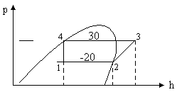

1. The COP of refrigeration & explain why it is less than that for (b)
2. The compressor power input necessary to achieve 10 kW of refrigeration
3. The mass flow of refrigerant per ton of refrigeration (1 "ton" = 3.52 kW)
4. The pressure in the evaporator and condenser

[Ans (c) (i) 4.07, (ii) 2.46 kW, (iii) 3.21 × 10-³ kg/s, (iv) 190 kPa.a, 1167 kPa.a]

Using the ammonia p-h chart tables draw its refrigeration cycle

### **Effects of heat exchanger operating conditions on the performance of the vapour compression refrigeration cycle**

d) A fan is installed in the refrigerated hold to improve the heat transfer coefficient between the evaporator and the air in the hold. The effect of this is that there is now a 3°C difference between the evaporating fluid and the hold. Given that the condensing temperature is the same as c) and ammonia is still the working fluid,

1. Determine the COP of refrigeration, and contrast this & the p-h diagrams for c) and d).
2. Determine the compressor power input necessary to achieve 10 kW of refrigeration & contrast this to that of c).
3. If the fan power requirement is 0.30kW, is the total power consumption of d) more or less than that of c) assuming the power spent circulating sea water through the condenser is the same in both, and that 10 kW of refrigeration is being done by both?

[Ans. d): (i) 4.57, (ii) 2.19 kW, (iii) 0.03kW more]

Using the ammonia p-h chart tables draw its refrigeration cycle, compare with the cycle in (c)

e) For the arrangement described in c) the condensing temperature was 30°C and you are also now informed that the temperature of the sea water leaving the condenser was 25°C. (The incoming water was 17°C).

1. Sketch the temperature distribution in the condenser and calculate the arithmetic mean temperature difference between the condensing ammonia and the water [Note: log mean temp difference is a more accurate tool but we will take the cruder approach in this exercise.]
2. It is decided to reduce the water flow rate to 2/3 what it was with a view to reducing water pumping power and hopefully the overall power consumption. Assuming the rate of heat rejection in the condenser is still the same, determine:

*[A]* -the leaving water temperature given that the incoming is still 17°C

*[B]* -the new arithmetic mean temperature difference if the overall heat transfer coefficient has been reduced to 0.75 times what it was before the flow was reduced.

*[C]* -the new condensing temperature and sketch the temperature distribution.

With this new condensing temperature, and the same evaporating temperature as in (c) ie -20°C, determine:

*[D]* -the COP and contrast this with that of (c). {Also contrast the respective p-h diagrams}.

*[E]* -the compressor power input necessary to achieve 10 kW of refrigeration and contrast this to that of (c)

*[F]* -the minimum reduction in water pumping power that must be achieved to make this change in conditions beneficial as regards overall power consumption compared to condition (c).

1. Sea water enters the condenser of a refrigeration plant at 17°C.
2. The water flow rate and rejected heat are such that the condensing temperature is 30°C and the sea water leaves at 25°C. Sketch the temperature distribution in the condenser and determine:
3. the AMTD
4. the LMTD
5. The water flow rate is half what it was in a), the overall heat transfer coefficient is 0.818 times what it was in a) but the quantity of heat to be handled is the same. Determine:
6. the new LMTD that is required in the condenser
7. the new leaving water temperature
8. the new condensing temperature

Sketch the new temperature distribution.

[Ans. a): i) 9°C, ii) 8.4°C b): i) 10.2°C, ii) 33°C, iii) 37.2°C]

1. For a refrigerator operating on a simple vapour compression cycle with: saturated liquid entering the throttle, dry saturated vapour entering the compressor, reversible and adiabatic compression, evaporation at -20°C and condensation at 30°C and using R12 as the refrigerant, plot the cycle R12 p-h charts and determine:
2. the pressure in the evaporator and condenser and contrast to those of ammonia determined in Q0.
3. the discharge temperature of the compressor and contrast with ammonia
4. the COP of refrigeration and contrast with ammonia
5. the mass flow of refrigerant per ton of refrigeration & contrast to ammonia
6. the volume flow rate of refrigerant per ton, entering the compressor & contrast to ammonia

[Ans (i) 150.9 kPa.a & 745 kPa.a for R12; 190 kPa.a & 1167 kPa.a for R717 (ii) 39.9°c for R12; 111°c for R717

(iii) 4.05 for R12; 4.09 for R717 (iv) 30.8 × 10  kg/sec for R12; 3.21 × 10  kg/sec for R717 (v) 3.35 × 10  m³ /sec for R12 2.00 × 10  m³ /sec for R717]

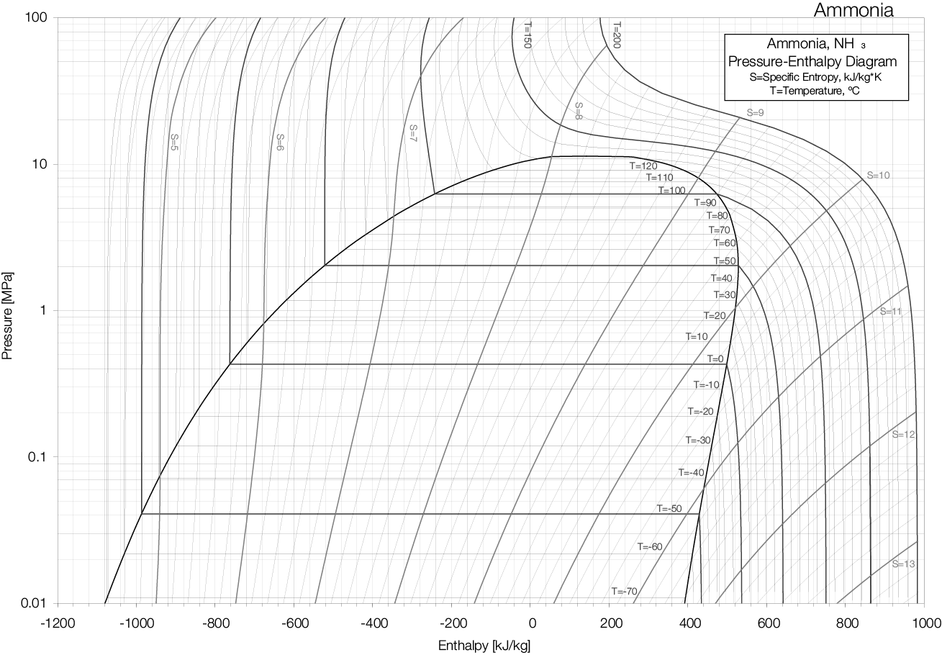

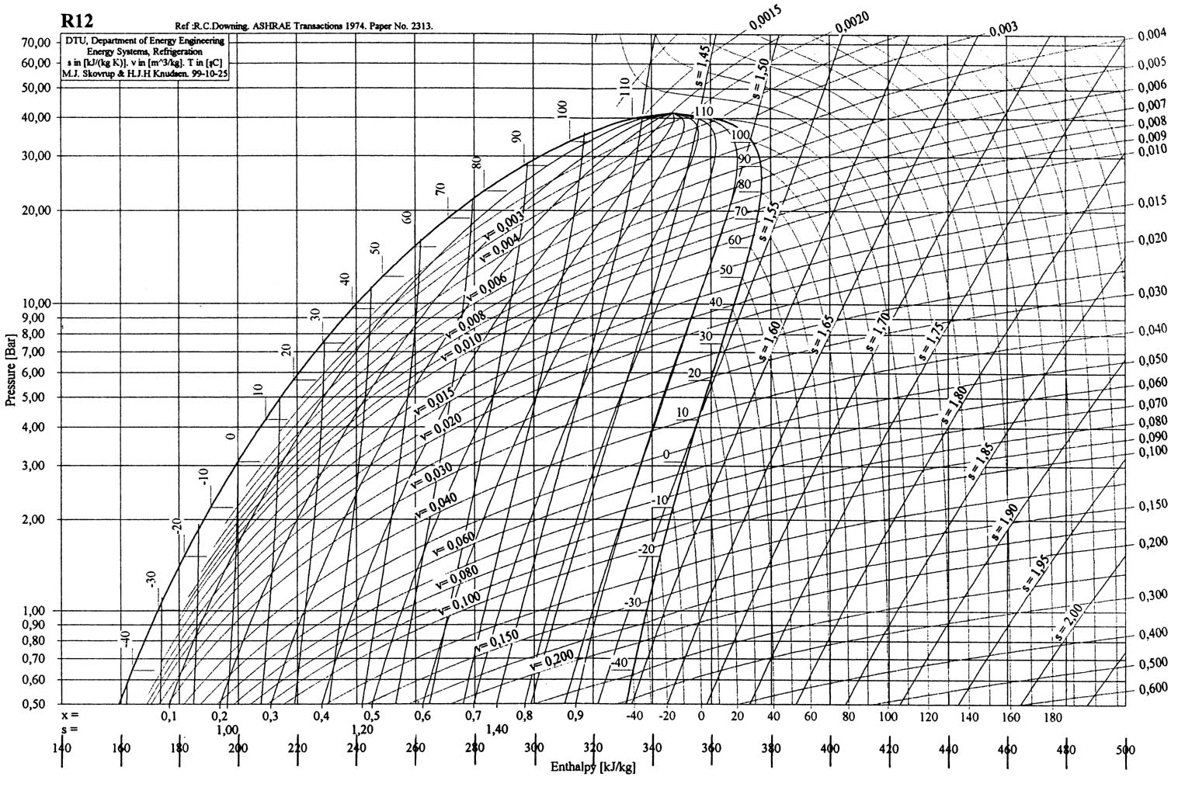

**Properties of Saturated Ammonia - Temperature Table**



**Properties of Saturated Ammonia – Superheated Table****Properties of Saturated Ammonia – Superheated Table**

